Министерство науки и высшего образования Российской Федерации

Федеральное государственное автономное образовательное учреждение

высшего образования

**«Пермский национальный** **исследовательский политехнический университет»**

Факультет: Прикладной математики и механики

Кафедра: Вычислительной математики, механики и биомеханики

Направление: 09.03.02 «Информационные системы и технологии»

Программа: «Информационные системы и технологии»

**ЛАБОРАТОРНАЯ РАБОТА**

по дисциплине

**«Интеллектуальные информационные системы и технологии»**

Тема: **«Проектирование и реализация продукционной базы знаний»**

Выполнил:

студент гр. ИСТ-19-1бзу

_____________________________________________________

Неганов Д.А.

_____________________________________________________

(Ф.И.О.)

Принял:

Старший преподаватель Истомин Д.А.

*______________________________________________________*

*(должность, ФИО руководителя)*

**Пермь 2022**

**Цель:**

Сформировать у студентов способность проектирования и разработки базы знаний, основанной на продукционной модели их представления.

**Описание:**

В рамках данной работы необходимо спроектировать продукционную БЗ, а также реализовать данную БЗ с использованием существующих инструментальных средств разработки ЭС (CLIPS). Также работа позволит ознакомиться с тем, как функционально работают существующие оболочки ЭС для того, чтобы облегчить в дальнейшем работы по созданию собственной оболочки ЭС. **Выполнение работы:**

Спроектированная и разработанная база знаний позволяет найти наиболее подходящую книгу, опираясь на предпочтения пользователя.

И\ИЛИ граф отображен на рисунке 1.

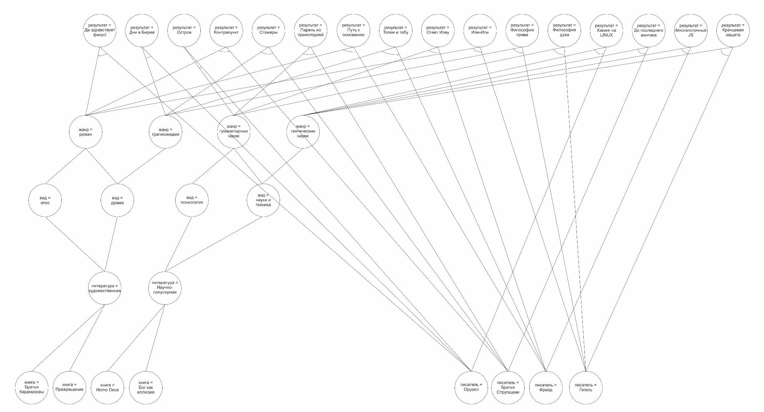

Рисунок 1. И\ИЛИ граф

На основании И\ИЛИ графа, с помощью CLIPS, была разработана продукционная база знаний:

;;****************

;;* DEFFUNCTIONS *

;;****************

(deffunction ask-question (?question $?allowed-values)

(printout t ?question)

(bind ?answer (read))

(if (lexemep ?answer)

then (bind ?answer (lowcase ?answer))

)

(while (not (member$ ?answer ?allowed-values)) do

(printout t ?question)

(bind ?answer (read))

(if (lexemep ?answer)

then (bind ?answer (lowcase ?answer)))

)

?answer

)

(deffunction ask-question-range (?question ?min ?max)

(printout t ?question)

(bind ?answer (read))

(while (or (not (numberp ?answer)) (> ?answer ?max) (< ?answer ?min)) do

(printout t ?question)

(bind ?answer (read))

)

?answer

)

;;;***************

;;;* QUERY RULES *

;;;***************

(defrule book "Книга"

(not (favorite-book ?))

(not (repair ?))

=>

(assert (favorite-book (ask-question-range

"Choose your favorite book (1.brothers-karamazov/2.metamorphosis/3.homo-deus/4.god-as-illusion)? "

1 4

)))

)

(defrule writer "Писатель"

(not (favorite-writer ?))

(not (repair ?))

=>

(assert (favorite-writer (ask-question

"Choose your favorite writer (orwell/strugatsky/freud/gegel)? "

orwell strugatsky freud gegel

)))

)

(defrule literature-fiction-type "Тип художественной литературы"

(favorite-liter fiction)

(not (liter-type ?))

(not (repair ?))

=>

(assert (liter-type (ask-question

"Choose the type of literature (epic/drama)? "

epic drama

)))

)

(defrule literature-popular-type "Тип научно-популярной литературы"

(favorite-liter popular)

(not (liter-type ?))

(not (repair ?))

=>

(assert (liter-type (ask-question

"Choose the type of literature (psychology/science)? "

psychology science

)))

)

(defrule literature-fiction-genre "Жанр художественной литературы"

(liter-type drama)

(not (liter-genre ?))

(not (repair ?))

=>

(assert (liter-genre (ask-question

"Choose a genre of literature (roman/tragicomedy)? "

roman tragicomedy

)))

)

(defrule literature-popular-genre "Жанр научно-популярной литературы"

(liter-type science)

(not (liter-genre ?))

(not (repair ?))

=>

(assert (liter-genre (ask-question

"Choose a genre of literature (humanitarian/technical)? "

humanitarian technical

)))

)

;;;**********************

;;;* INTERMEDIATE RULES *

;;;**********************

;Определяем литературу

(defrule literature-fiction ""

(or

(favorite-book 1)

(favorite-book 2)

)

(not (favorite-liter ?))

(not (repair ?))

=>

(assert (favorite-liter fiction))

)

(defrule literature-popular ""

(or

(favorite-book 3)

(favorite-book 4)

)

(not (favorite-liter ?))

(not (repair ?))

=>

(assert (favorite-liter popular))

)

;Определяем жанр

(defrule literature-genre-roman ""

(liter-type epic)

(not (liter-genre ?))

(not (repair ?))

=>

(assert (liter-genre roman))

)

(defrule literature-genre-psychology ""

(liter-type psychology)

(not (liter-genre ?))

(not (repair ?))

=>

(assert (liter-genre humanitarian))

)

;;;****************

;;;* REPAIR RULES *

;;;****************

(defrule repair-hello-ficus ""

(liter-genre roman)

(favorite-writer orwell)

(not (repair ?))

=>

(assert (repair "Keep the Aspidistra Flying"))

)

(defrule repair-point-conter-point ""

(liter-genre roman)

(favorite-writer strugatsky)

(not (repair ?))

=>

(assert (repair "Point Counter Point"))

)

(defrule repair-forward-foundation ""

(liter-genre roman)

(favorite-writer freud)

(not (repair ?))

=>

(assert (repair "Forward the Foundation"))

)

(defrule repair-or-or ""

(liter-genre roman)

(favorite-writer gegel)

(not (repair ?))

=>

(assert (repair "Or-Or"))

)

(defrule repair-burmese-days ""

(liter-genre tragicomedy)

(favorite-writer orwell)

(not (repair ?))

=>

(assert (repair "Burmese Days"))

)

(defrule repair-interns ""

(liter-genre tragicomedy)

(favorite-writer strugatsky)

(not (repair ?))

=>

(assert (repair "Interns"))

)

(defrule repair-totem-taboo ""

(liter-genre tragicomedy)

(favorite-writer freud)

(not (repair ?))

=>

(assert (repair "Totem and Taboo"))

)

(defrule repair-philosophy-right ""

(liter-genre tragicomedy)

(favorite-writer gegel)

(not (repair ?))

=>

(assert (repair "Elements of the Philosophy of Right"))

)

(defrule repair-island ""

(liter-genre humanitarian)

(favorite-writer orwell)

(not (repair ?))

=>

(assert (repair "Island"))

)

(defrule repair-kid-from-hell ""

(liter-genre humanitarian)

(favorite-writer strugatsky)

(not (repair ?))

=>

(assert (repair "The Kid from Hell"))

)

(defrule repair-answer-to-job ""

(liter-genre humanitarian)

(favorite-writer freud)

(not (repair ?))

=>

(assert (repair "Answer to Job"))

)

(defrule repair-philosophy-spirit ""

(liter-genre humanitarian)

(favorite-writer gegel)

(not (repair ?))

=>

(assert (repair "Philosophy of spirit"))

)

(defrule repair-hacking-linux ""

(liter-genre technical)

(favorite-writer orwell)

(not (repair ?))

=>

(assert (repair "Hacking on LINUX"))

)

(defrule repair-last-screw ""

(liter-genre technical)

(favorite-writer strugatsky)

(not (repair ?))

=>

(assert (repair "Until the last screw"))

)

(defrule repair-multithreaded-js ""

(liter-genre technical)

(favorite-writer freud)

(not (repair ?))

=>

(assert (repair "Multithreaded Javascript"))

)

(defrule repair-fender-protection ""

(liter-genre technical)

(favorite-writer gegel)

(not (repair ?))

=>

(assert (repair "Fender protection"))

)

;;;********************************

;;;* STARTUP AND CONCLUSION RULES *

;;;********************************

(defrule system-banner ""

(declare (salience 10))

=>

(printout t crlf crlf)

(printout t "Book recommendation system")

(printout t crlf crlf)

)

(defrule print-repair ""

(declare (salience 10))

(repair ?item)

=>

(printout t crlf crlf)

(printout t "Recommended book:")

(printout t crlf crlf)

(format t " %s%n%n%n" ?item)

На основании проделанной работы написаны правила IF\THEN:

//QUERY RULES

Rule "book"

IF "favorite-book" = ? AND "repair" = ? THEN "favorite-book" = (Choose your favorite book)

Rule "writer"

IF "favorite-writer" = ? AND "repair" = ? THEN "favorite-writer" = (Choose your favorite writer)

Rule "literature-fiction-type"

IF "favorite-liter" = fiction AND "liter-type" = ? AND "repair" = ? THEN "liter-type" = (Choose the type of literature)

Rule "literature-popular-type"

IF "favorite-liter" = popular AND "liter-type" = ? AND "repair" = ? THEN "liter-type" = (Choose the type of literature)

Rule "literature-fiction-genre"

IF "liter-type" = drama AND "liter-genre" = ? AND "repair" = ? THEN "liter-genre" = (Choose a genre of literature)

Rule "literature-popular-genre"

IF "liter-type" = science AND "liter-genre" = ? AND "repair" = ? THEN "liter-genre" = (Choose a genre of literature)

//INTERMEDIATE RULES

Rule "literature-fiction"

IF "favorite-book" = 1 OR "favorite-book" = 2 AND "favorite-liter" = ? AND "repair" = ? THEN "favorite-liter" = fiction

Rule "literature-popular"

IF "favorite-book" = 3 OR "favorite-book" = 4 AND "favorite-liter" = ? AND "repair" = ? THEN "favorite-liter" = popular

Rule "literature-genre-roman"

IF "liter-type" = epic AND "liter-genre" = ? AND "repair" = ? THEN "liter-genre" = roman

Rule "literature-genre-psychology"

IF "liter-type" = psychology AND "liter-genre" = ? AND "repair" = ? THEN "liter-genre" = humanitarian

//REPAIR RULES

Rule "repair-hello-ficus"

IF "liter-genre" = roman AND "favorite-writer" = orwell AND "repair" = ? THEN "repair" = Keep the Aspidistra Flying

Rule "repair-point-conter-point"

IF "liter-genre" = roman AND "favorite-writer" = strugatsky AND "repair" = ? THEN "repair" = Point Counter Point

Rule "repair-forward-foundation"

IF "liter-genre" = roman AND "favorite-writer" = freud AND "repair" = ? THEN "repair" = Forward the Foundation

Rule "repair-or-or"

IF "liter-genre" = roman AND "favorite-writer" = gegel AND "repair" = ? THEN "repair" = Or-Or

Rule "repair-burmese-days"

IF "liter-genre" = tragicomedy AND "favorite-writer" = orwell AND "repair" = ? THEN "repair" = Burmese Days

Rule "repair-interns"

IF "liter-genre" = tragicomedy AND "favorite-writer" = strugatsky AND "repair" = ? THEN "repair" = Interns

Rule "repair-totem-taboo"

IF "liter-genre" = tragicomedy AND "favorite-writer" = freud AND "repair" = ? THEN "repair" = Totem and Taboo

Rule "repair-philosophy-right"

IF "liter-genre" = tragicomedy AND "favorite-writer" = gegel AND "repair" = ? THEN "repair" = Elements of the Philosophy of Right

Rule "repair-island"

IF "liter-genre" = humanitarian AND "favorite-writer" = orwell AND "repair" = ? THEN "repair" = Island

Rule "repair-kid-from-hell"

IF "liter-genre" = humanitarian AND "favorite-writer" = strugatsky AND "repair" = ? THEN "repair" = The Kid from Hell

Rule "repair-answer-to-job"

IF "liter-genre" = humanitarian AND "favorite-writer" = freud AND "repair" = ? THEN "repair" = Answer to Job

Rule "repair-philosophy-spirit"

IF "liter-genre" = humanitarian AND "favorite-writer" = gegel AND "repair" = ? THEN "repair" = Philosophy of spirit

Rule "repair-hacking-linux"

IF "liter-genre" = technical AND "favorite-writer" = orwell AND "repair" = ? THEN "repair" = Hacking on LINUX

Rule "repair-last-screw"

IF "liter-genre" = technical AND "favorite-writer" = strugatsky AND "repair" = ? THEN "repair" = Until the last screw

Rule "repair-multithreaded-js"

IF "liter-genre" = technical AND "favorite-writer" = freud AND "repair" = ? THEN "repair" = Multithreaded Javascript

Rule "repair-fender-protection"

IF "liter-genre" = technical AND "favorite-writer" = gegel AND "repair" = ? THEN "repair" = Fender protection